

Motor Controller

ME 305-03

December 7, 2015

Carter Price

Sarah Visitacion

**Objective**

The objective of this lab was to create a motor velocity controller. The system receives a reference voltage,KI and KP as input from the user and then controls the motor speed. The user has an option to do open loop or closed loop feedback. A brief summary pertinent motor specifications and characteristics can be found below.

**Input vs Output Voltage**

The control loop gain K is one of the important characteristics for the controller. This was found by plotting the reference or input velocity vs the actual velocity of the motor in open loop steady state.

**Figure 1: Open Loop Steady-state- with Kp= 5; Vref vs. Vout**

The slope of the line seen in figure 1 is equal to K * Kp. Therefore, the resulting K is equal to 0.1394. The next step in the motor analysis is to look at the time constant. Τm.

The time constant is found by plotting the step response of the motor. The reference voltage was taken from 0 to 100 and plotted. The resulting output seen by the oscilloscope from the step response can be found in figure 2.

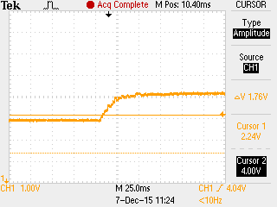

**Figure 2: Open loop step response to find time constant.**

The time constant is the time it take the output to reach 63.2% of its final state. The resulting τm is 0.014 seconds. The time constant was calculated both using the oscilloscope and the specific data points in excel to ensure accuracy.

The next step was to find the motor constant Km. The motor constant is one of the gains that combines to form K.. The motor constant Km was found to be 9.4 (calculation in appendix A).

Now with the Km, τm, and K, the closed loop system parameters can be looked at. Based on the derived closed loop transfer function, the systems natural frequency ( ) and damping constant ( ) were found at Kp = 5 and KI = 1. The formulas and calculations can be seen in Appendix A. Below in figure 3 is a graph comparing the closed loop step response and the Simulink model when a step of 0 to 100 is provided for Vref.

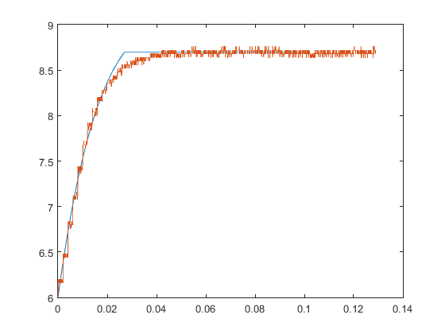

**Figure 3: Step-response with a Kp of 5 and Ki of 1.**

In figure 3, the actual response seems to match the Simulink model pretty closely. However, the actual response seems to tail off toward saturation while the Simulink model hits the saturation point hard.

Finally, given that the natural frequency increase by a factor of 2.5 and damping constant remains the same (Calcs seen in Appendix A). The new Kp and KI were found. The results compared with Simulink model can be found below in figure 4.

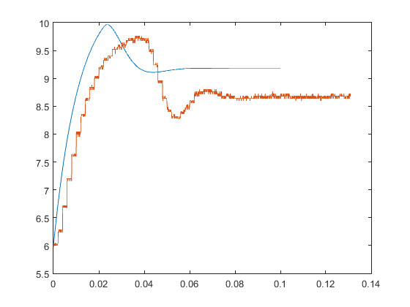

**Figure 4: Step response with Ki = 6.25 and Kp = 12.37**

The actual response and the Simulink model seem to match well because they have a similar shape. However, the Simulink model seems to have a faster response time. This is partially due to slight horizontal offset between the graphs.

**Table 1: Summary system parameters**

|  |  |  |
| --- | --- | --- |
| ~~K~~ | τm | Km |
| 0.1394 | 0.014 s | 9.4 |

**Table 2: Closed loop parameters**

|  |  |  |  |
| --- | --- | --- | --- |
| For Kp = 5 and KI = 1 | | For ωn = 176.78 and ζ = 2.97 | |
| ωn | ζ | Kp | KI |
| 70.71 | 2.97 | 12.37 | 6.25 |